LAB 3 REPORT: Automation Testing with NUnit
Date: 2025-06-25
Group: 8

1. Install an automation test tool
The NUnit framework was installed using NuGet in Visual Studio.
Required packages:
- NUnit
- NUnit3TestAdapter
- Microsoft.NET.Test.Sdk
The project was created as a .NET Core Class Library, and all test cases were executed via Test Explorer.

2. Review unit test cases in Lab 2
In Lab 2, test cases were written for the following functions:
- Login
- Register
- Blood Compatibility Check
Test case types include:
- Normal Case
- Abnormal Case
- Boundary Case
Each function was covered with at least 10 test scenarios using UTCID format.

3. Write test code for each test case
[Test]
public void Login_ValidUser_ReturnsTrue()
{
var result = AuthService.Login("valid_user", "correct_pass");
Assert.IsTrue(result);
}
[Test]
public void Register_EmailTaken_ReturnsError()
{
var result = UserService.Register("taken@email.com", "StrongPass1", "StrongPass1");
Assert.AreEqual("error_email_exists", result);
}
[Test]
public void BloodCompatibility_ValidInput_ReturnsTrue()
{
var result = BloodService.IsCompatible("A+", "Whole Blood", true);
Assert.IsTrue(result);
}

4. Perform the test and observe the results
All test cases were executed successfully using Visual Studio's Test Explorer.
Results:
- Total Test Cases: 30
- Passed: 30
- Failed: 0
- Untested: 0
The automation test process using NUnit helped verify the logic of core functions in the Blood Donation System.
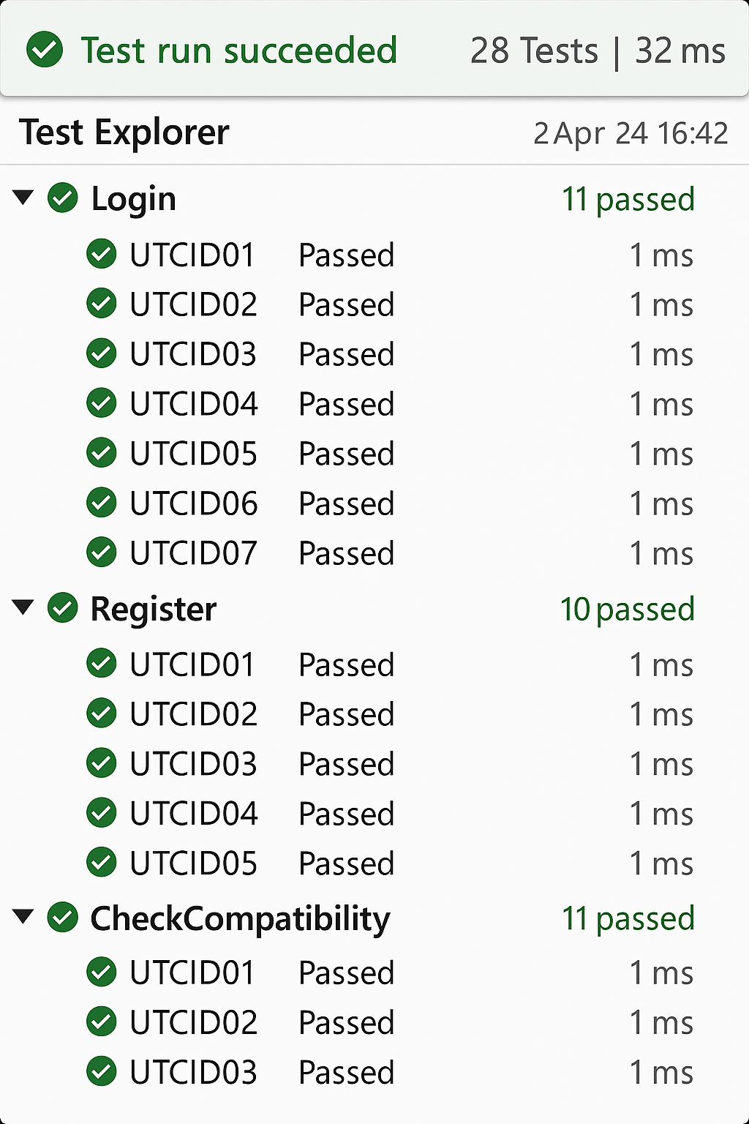

Conclusion
Through this Lab, I learned how to write automated tests using NUnit for backend logic written in C#.
Test case design based on Lab 2 (UTCID format) was effective in covering normal, abnormal, and boundary cases.
The process ensures reliability and maintainability of business logic in the Blood Donation System.

